Each day

Morning moves:
- Andy’s Wild Workouts (https://www.bbc.co.uk/programmes/p06tmmvz)
- Kid’s workouts from Sport England (Superheroes – https://www.youtube.com/channel/UCokO71NW3TgndaSNyHIqwtQ)
- Disney dance-a-longs: https://www.thisgirlcan.co.uk/activities/disney-workouts/
- Cosmic yoga: https://www.youtube.com/user/CosmicKidsYoga

Phonics @ 10:30: https://www.youtube.com/channel/UCP_FbjYUP_UtldV2K_-niWw/featured

Maths: https://whiterosemaths.com/homelearning/year-1/

English: https://classroom.thenational.academy/schedule-by-year/year-1/

Session | Monday | Tuesday | Wednesday | Thursday
1 | Watch ‘The Hidden Forest’  https://www.youtube.com/watch?v=3Uxig3fcZHA (Remember you can turn the sound off and have a go at reading it!)  With an adult, discuss: What would you like to have seen most if you were diving in the sea?  STEM: Beach ball challenge  Using anything you have around the house, make a tower that can hold a beach ball (or any other light ball) on top. You could use toilet rolls, paper, plastic bottles etc. How tall can you make your tower? Can you make your tower wider? Narrower?  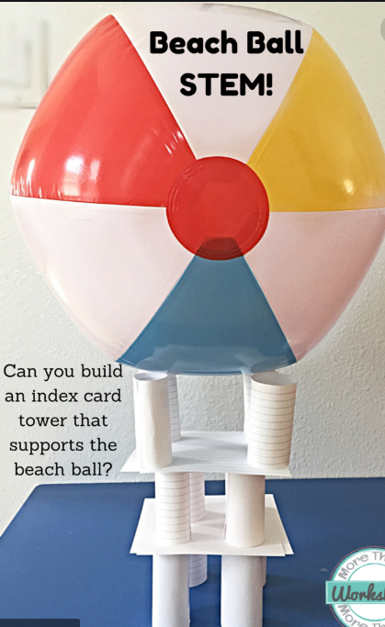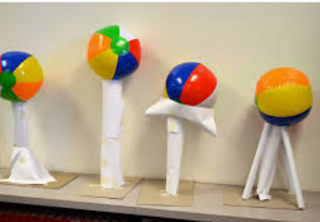 | Art  Create a sea scene. Follow the instructions here.  https://buggyandbuddy.com/ocean-art-project-for-kids-using-watercolor-and-salt/  Note:  Wax crayons will work as well as oil pastels. | PSHE  Watch the links from...  https://www.downshireps.co.uk/ocean-stories/  Discuss why it is important to look after the environment.  List the things you can do to help. Illustrate your list. | DT  Create your own fishing game. Here is an idea…  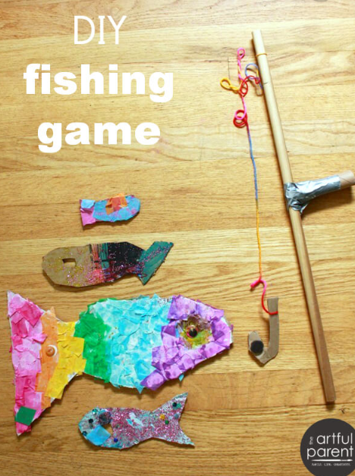  If you don’t have a magnet you could try turning a paper clip into a hook to ‘hook’ your fish
2 | STEM  Make a floating boat. Follow the instructions here...  https://www.thesprucecrafts.com/easy-origami-boat-instructions-4057416  Does your boat work? Can you add a sail to it? Does it still float? Can you put anything inside? What’s the heaviest thing your boat can carry? Can you make a smaller/bigger boat? Will this hold more or less weight? | STEM  Capacity investigation  Pick a range of different shapes items that could contain water (find some of a similar size to add to the challenge).  Put the containers in order of smallest to largest capacity. How did you find out which contained (could hold) more/less? | Art  Create your own Puffer Fish by using a fork to show its texture (see picture below).  Can you paint any other sea creatures using this method?  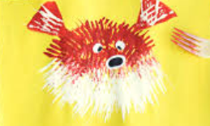  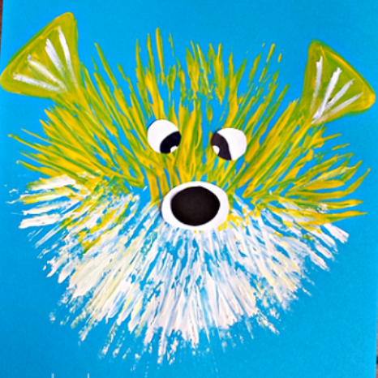 | English  Choose an Andy’s Aquatic Adventure to watch  https://www.bbc.co.uk/iplayer/episode/m000fsw6/andys-aquatic-adventures-series-1-15-andy-and-the-hawksbill-turtles  Make a fact sheet of all the things you have learnt.

