Every day, we do one session of the following:

Maths https://whiterosemaths.com/homelearning/year-1/ (see our maths page for more details)

10.30 Phonics https://www.youtube.com/channel/UCP_FbjYUP_UtldV2K_-niWw/featured (see our English page for more details)

English https://classroom.thenational.academy/schedule-by-year/year-1/ (see our English page for more details)

P.E.:
- Andy’s Wild Workouts (https://www.bbc.co.uk/programmes/p06tmmvz)
- Kid’s workouts from Sport England (Superheroes - https://www.youtube.com/channel/UCokO71NW3TgndaSNyHIqwtQ
- Disney dance-a-longs - https://www.thisgirlcan.co.uk/activities/disney-workouts/
- Cosmic yoga: https://www.youtube.com/user/CosmicKidsYoga

Session | Monday | Tuesday | Wednesday | Thursday
1 | - First, watch The Great Dog Bottom Swap https://www.youtube.com/watch?v=WPZjT_oLPfs  - Then, look at these two websites which explain how to take care of pets…  https://www.bbc.co.uk/cbeebies/topics/pets  https://www.pdsa.org.uk/taking-care-of-your-pet/looking-after-your-pet  - After that, read the Twinkl PowerPoint which is saved on our homepage and explain how to look after a pet.  - Finally, choose a pet and draw it. Around your picture write facts about how to look after it. | Watch Collecting Cats https://www.youtube.com/watch?v=DC39xHjqTxM  On some paper/card draw the outline of your favourite pet. Cut this out and then decorate with anything you can find outside.  Here is an example… | Complete this reading comprehension  https://learnenglishkids.britishcouncil.org/worksheets/looking-after-pets | Watch Peter Rabbit on cbeebies https://www.bbc.co.uk/iplayer/episodes/b052sx2p/peter-rabbit  Now watch this clip of a real rabbit warren https://youtu.be/qkiqTmvgdx8  Make a list of what is the same and what is different about Peter’s house.
2 | Create your own leaf pets. Here are some examples…  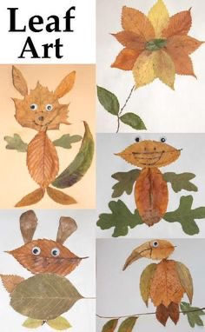  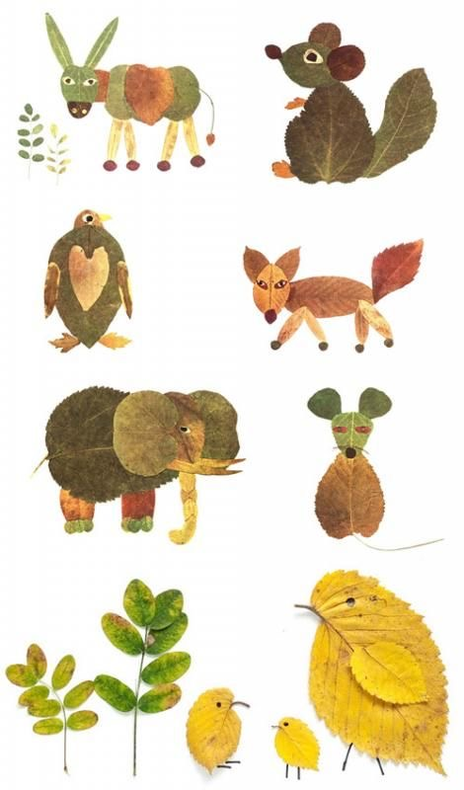 | Watch these instructions to  make your own paper dog…  https://youtu.be/fBeXZLShcUE  Using this idea try and make a paper cat instead. Write the instructions to help someone else make a paper cat. | Science  Read through the Twinkl PowerPoint on Mini beast habitat which is saved on our home page.  Find a minibeast. What is its habitat like?  Recreate your minibeasts habitat somewhere else outside (not far from the original place you found it). Put your minibeast there. Do they like it? Have you made any improvements? Is there anything you need to change? | Rabbit Crafts  Have a look at these crafts and try to recreate one yourself…  