These happen daily.

P.E
Here are some of the website we will be using in the classroom to exercise and re-focus on our work:
- Andy’s Wild Workouts (https://www.bbc.co.uk/programmes/p06tmmvz)
- Kid’s workouts from Sport England (Superheroes - https://www.youtube.com/channel/UCokO71NW3TgndaSNyHIqwtQ)
- Disney dance-a-longs - https://www.thisgirlcan.co.uk/activities/disney-workouts/
- Cosmic yoga: https://www.youtube.com/user/CosmicKidsYoga
- Joe Wicks Workout: YouTube

Phonics
See our English page for more information on which session to follow: https://www.youtube.com/channel/UCP_FbjYUP_UtldV2K_-niWw/featured

Maths:
See our maths page for this week’s programme: https://whiterosemaths.com/homelearning/year-1/

English:
See our maths page for this week’s programme: https://classroom.thenational.academy/schedule-by-year/year-1/

The resources used in the classroom can be found below this week’s planning. If you do not have access to a printer, feel free to adapt each session to suit what you have available in your home.

Session | Monday | Tuesday | Wednesday | Thursday
1 | Watch “The Colour Monster”  The Colour Monster being read out. Turn off the sound and try reading it yourself. | Recap the story heard yesterday. Can you remember how did the colour monster feel at the beginning?  Watch  Natural Glitter  to see how to make natural glitter.  Fill the Colour Monster (Resource 2) with your own natural glitter  After that, try to draw and make your own colour monster in natural glitter, showing how you feel today. | Make a list of all the things that make you happy and content. | Find a seed – this may be one you already have such as a bean or sunflower or you could find one in an apple, lemon, pear.  Plant your seed.
2 | Find a pebble and paint your face onto it. | Paper blocks  Watch this video: https://babbledabbledo.com/science-for-kids-paper-building-blocks/  Create your own paper blocks and use these to build a monster. | Discuss how gardening makes people relaxed. Look at tips for gardening with kids  https://www.bbc.co.uk/cbeebies/grownups/7-tips-for-gardening-with-children | Watch https://www.bbc.co.uk/bitesize/topics/zpxnyrd/articles/z2vdjxs  Draw what you think your plant will look like in 7 days’ time.
3 | Colour in the jars (Resource 1) the correct colour from the story. How are you feeling today? Put your painted stone on how you are feeling. Explain what made you put your stone here. | Fizzy painting  Create confused monsters using fizzy painting. Then cut out a monster shape, add eyes, ears and a mouth. Your monster is done!  https://taminglittlemonsters.com/fizzy-painting-stem-activity-for-kids/ | Go outside and make something outside look better. This could be by picking litter, weeding an area, planting something. How did it make you feel? | Imagine… if your flower was the colour of your emotion, what colour would it be?  Make your flower.

Resource 1
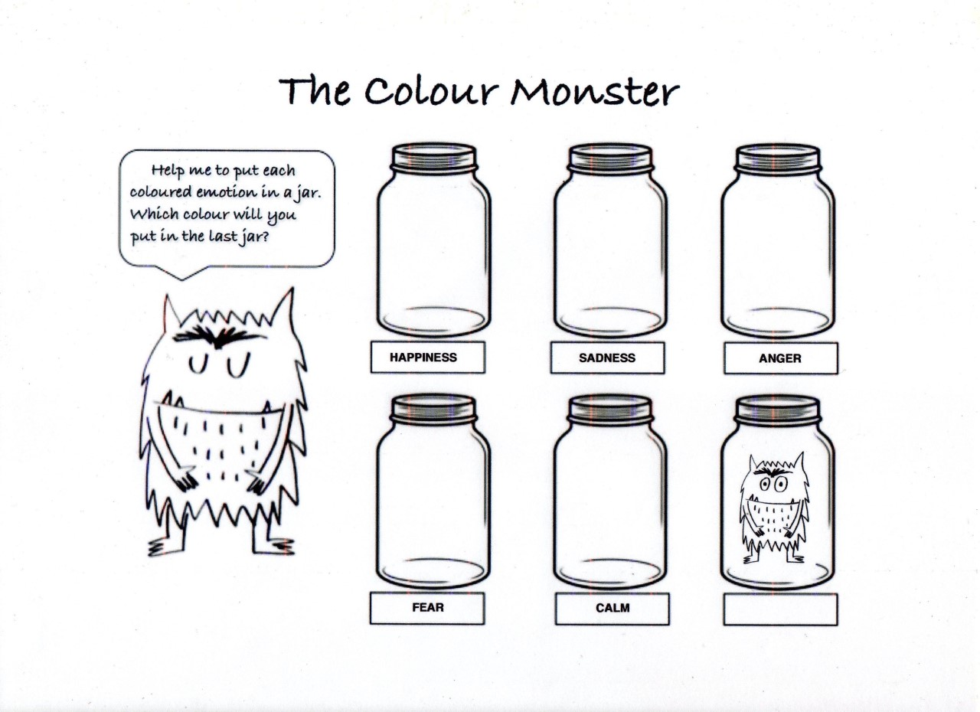

Resource 2

EXTRA ACTIVITES…
