Australia
Here are some interesting Australia Facts which were chosen and researched by kids especially for kids.
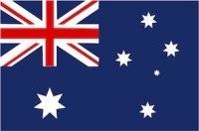
- Name: Commonwealth of Australia
- Government: Democracy
- Population: 25 million (2019)
- Urban Population: 90%
- Capital: Canberra with 403,000 people (2019)
- Language: English
- Unemployment: 12.7%
- Currency: 1 Australian Dollar=100 Cents
- Religion: mainly Christians
- Timezones: 3
- National Symbols: Golden wattle (flower), opal (gemstone), green and gold (colours)
- National Holiday: 26 January (Australia Day)
Australia is a country in the Southern hemisphere and belongs to Oceania. Australia/Oceania is the smallest continent of the seven continents and many consider it as the largest island in the world, however, Greenland is the biggest island country. Australia is an island continent surrounded by the Indian Ocean and the Pacific Ocean.
Australia is the sixth largest country in the world, after Russia, Canada, USA, China and Brazil.
The country is divided into six states (Southern Australia, Western Australia, New South Wales, Queensland, Victoria and Tasmania) and two self-governing territories: Northern Territory and Australian Capital Territory (which is around Canberra, the capital city).
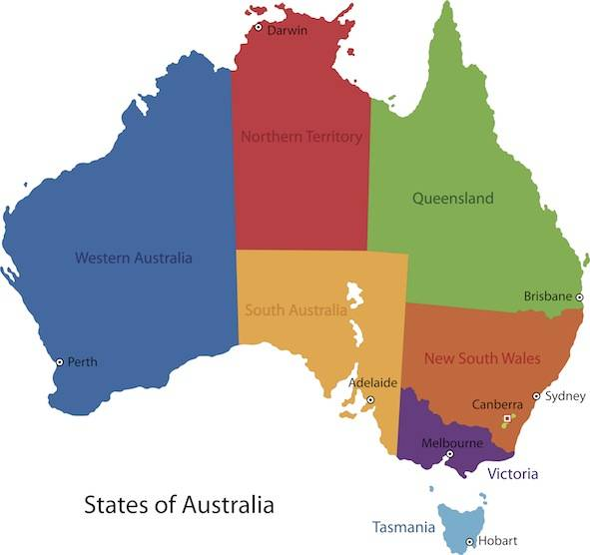
The main cities in Australia are: Sydney, Melbourne, Perth, Brisbane, Darwin, Adelaide, Hobart and Canberra (capital city). The cities are all located at the coast or close to the coast.
The country's interior, which covers two thirds of the country, consist of desert landscape which is referred to as 'outback'. The main city in the country's interior is Alice Springs.

Australia Facts:
Australia Attractions for Kids
There are many great attractions in the country. Some of these are:
- Adelaide: the main city in South Australia is surrounded with fertile agricultural and wine regions. Adelaide is also known for one of the largest Christmas parades in the world.
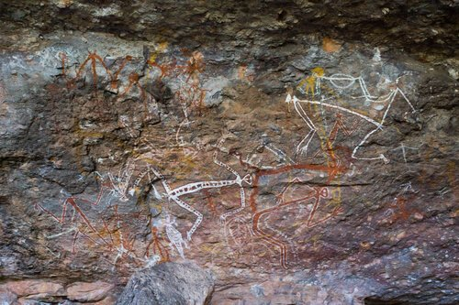Aboriginal rock art in Arnhem Land
- Australian Alps: Experience mountain landscapes in the snowy mountains and enjoy the fascinating remote wilderness. Great hiking in summer there too like here near lake Jindabyne.
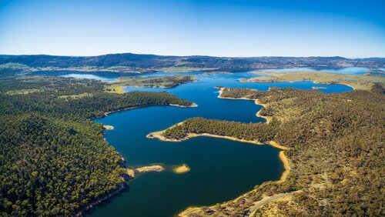
Aerial view of the Australian Alps around Lake Jindabyne
- Great Barrier Reef: Great for snorkelling and diving. Cairns is a popular beach resort town on the Northern Coast.
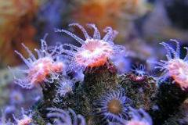
Corals at the Great Barrier Reef
- Kakadu National Park: Experience the excitement of a real jungle in Australia's biggest national park and one of the world's most unique forests and woodlands and one of Australia's UNESCO World Heritage Sites. There you can also admire the Northern Territories highest waterfalls, the Jim Jim Falls.
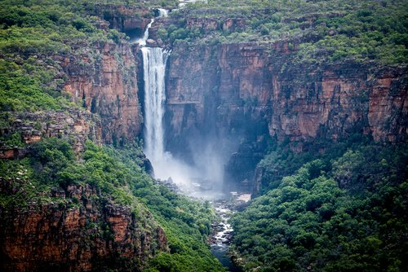
Jim Jim Falls

Australia - People
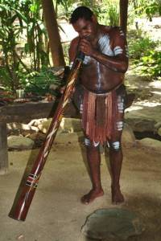
Australia's first or indigenous people, are usually referred to as the aboriginal people of Australia. They make up 2% of Australia's population today. The indigenous Australians are said to be direct descendants of migrants from Africa who left the African continent about 75,000 years ago. They have migrated over the Australasian continent until they settled in Australia around 60,000 years ago.
Today indigenous people live in all main cities but most of them still live in the desert areas of the Australian outback. On the image above, you can see a man playing the didgeridoo, a kind of wooden trumpet, which is really difficult to play.
The 'outback' is the vast, dry and remote inland parts of the Australian continent. Some aboriginal people live still in the sacred area around Ayres Rock, a huge rock formation in the centre of the continent. They are highly skilled in arts and crafts and share with visitors their vast knowledge about the land and the environment.
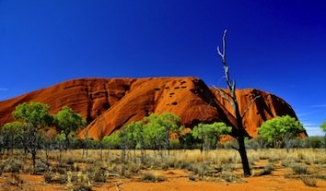Ayers Rock or Uluru as the rock formation is called by the aboriginal people of Australia
The indigenous people call this sacred mountain 'Uluru'. They also settle in the Northern Territory in Kakadu National Park, which they call 'Arnhem Land', the land of their ancestors.

Canada
Here are some interesting Canada Facts for Kids which were choosen and reseached by kids especially for kids.
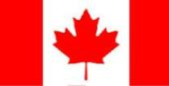
- Population: 36.9 million people (2018)
- Capital: Ottawa 1.3 million inhabitants (2018)
- Name: Canada
- Government: Democracy
- Languages: English, French
- Religion: mainly Christians (Roman Catholics and Protestants)
- Currency: 1 Canadian Dollar (CAD)=100 Canadian cents
- National Symbols: Maple leaf, beaver
- History: Canada's biggest bay, Hudson Bay, was discovered in 1610. Since the 16th century, both French and English kings have ruled over the country. Canada gained independence from Britain in 1867. Today, Queen Elizabeth II of England is also the Queen of Canada and the head of state. The prime minister elected by the people is Justin Trudeau.
- Canada is a country in the northern hemisphere. The country belongs to the North American continent and shares borders with the United States of America. Canada and the USA actually share the longest international border in the world. It is 8,891km/5,525miles long.
- The longest part of the border is shared with the US-state of Alaska and is more than 2,475km/1,538miles long.

Canada Geography
- Canada is the second biggest country in the world, after Russia - measured by total area!
- Canada is a sparsely populated country, most of the people live close to the US-Canada border where the main urban areas such as Vancouver, Montreal, Quebec are.
- Canada's longest river is the McKenzie River in the North West. The river is 2,635miles or 4,241km long.
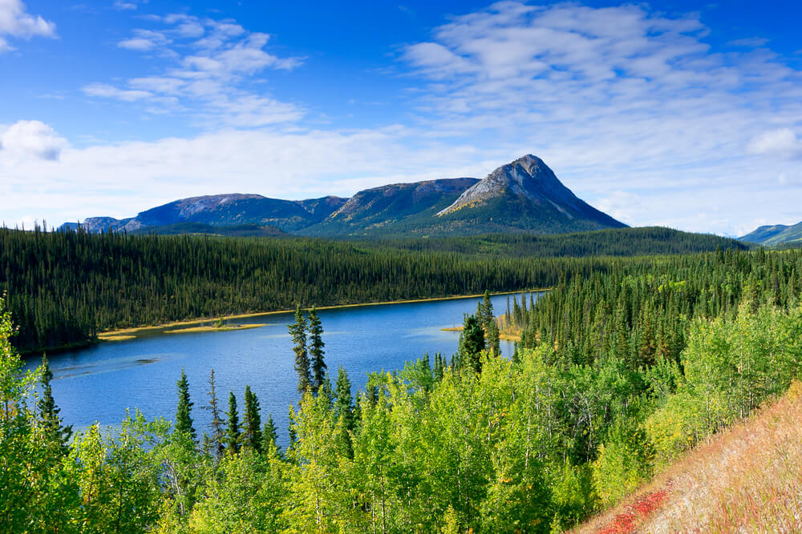
- The highest mountain in Canada is with 19,551ft or 5,959m the Mount Logan in the Yukon Territory at the border with Alaska.
- Canada has the largest waterfalls by water volume. These are the Niagara Falls.
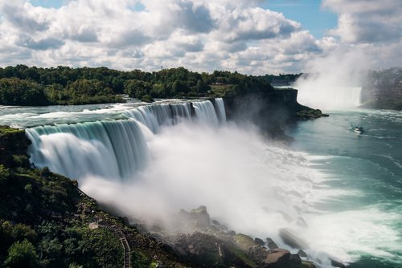
Niagara Falls

Canada Attractions for Kids
Canada is one of the most popular tourist destinations in the world. There are many attractions for Canada visitors and kids will love to explore the amazing nature and wildlife.
Families also can go on great canoe trips in the national parks or enjoy skiing and snowboarding and other winter fun activities in the mountains. But also the big cities such as Toronto, Quebec and Vancouver have lots to offer to families travelling with kids with stunning museums and wonderful city parks for great outdoor activities such as cycling, climbing, sledging or iceskating.

Canada Facts for Kids: Economy
- Canada is the second largest oil reserve holder after Saudi Arabia. The province of Alberta leads in the production of oil and natural gas in Canada.
- Canada is the leader in uranium mining. And uranium is used in nuclear power plants for producing electricity.
- The province of Saskatchewan is the main agricultural province in Canada and grows 45% of Canada's grain such as wheat, canola, flax or rye.
- Canada is the world leader of Hydro Electricity which uses the power of the water to produce electricity.

Canada Facts for Kids: Canada People
The Canadian people are called Canadians. Most of the Canadian families have roots in England and France, as during the French and British colonised the country and thus many families from 'the old world' immigrated into Canada.
Canada has two official languages: English and French. Almost half of the population can speak both languages. The majority of Canadians speak English as first language, but French is the main language in the Quebec province. In Quebec also almost half of the population is bilingual, which means that they are able to speak both languages fluently.
- Almost 90% of all Canadians live within 200km/125miles of the Canada-USA border!
- Main languages are English and French
- Inuit are one group of Canada's indigenous people
- Life expectancy at birth is 81 years
- Literacy Rate is 99%
Among the aboriginal people in Canada are the Métis, the First Nations People and the Inuit.
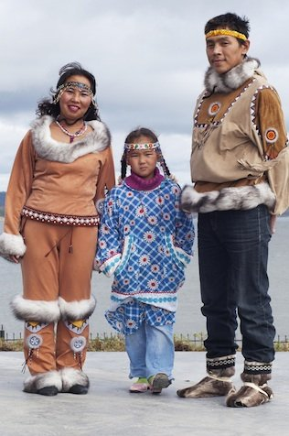Inuit Family
The indigenous people in northern Canada are called 'Inuit'. Inuit people, which were called 'eskimos' previously but this name is not acceptable and pejorative. Today, only 5 in 100 Canadians refer to themselves as 'Inuk' (one of the Inuit people).
The inuit live today in modern houses but still build igloos, especially when hunting. The inuit children go to the community's schools, but there are no universities in the North. So if the children decide to go on studying, they have to leave their communities and move to university cities. In the Inuit language, writing text was only begun in the 19th century before they mainly used symbols for writing.

